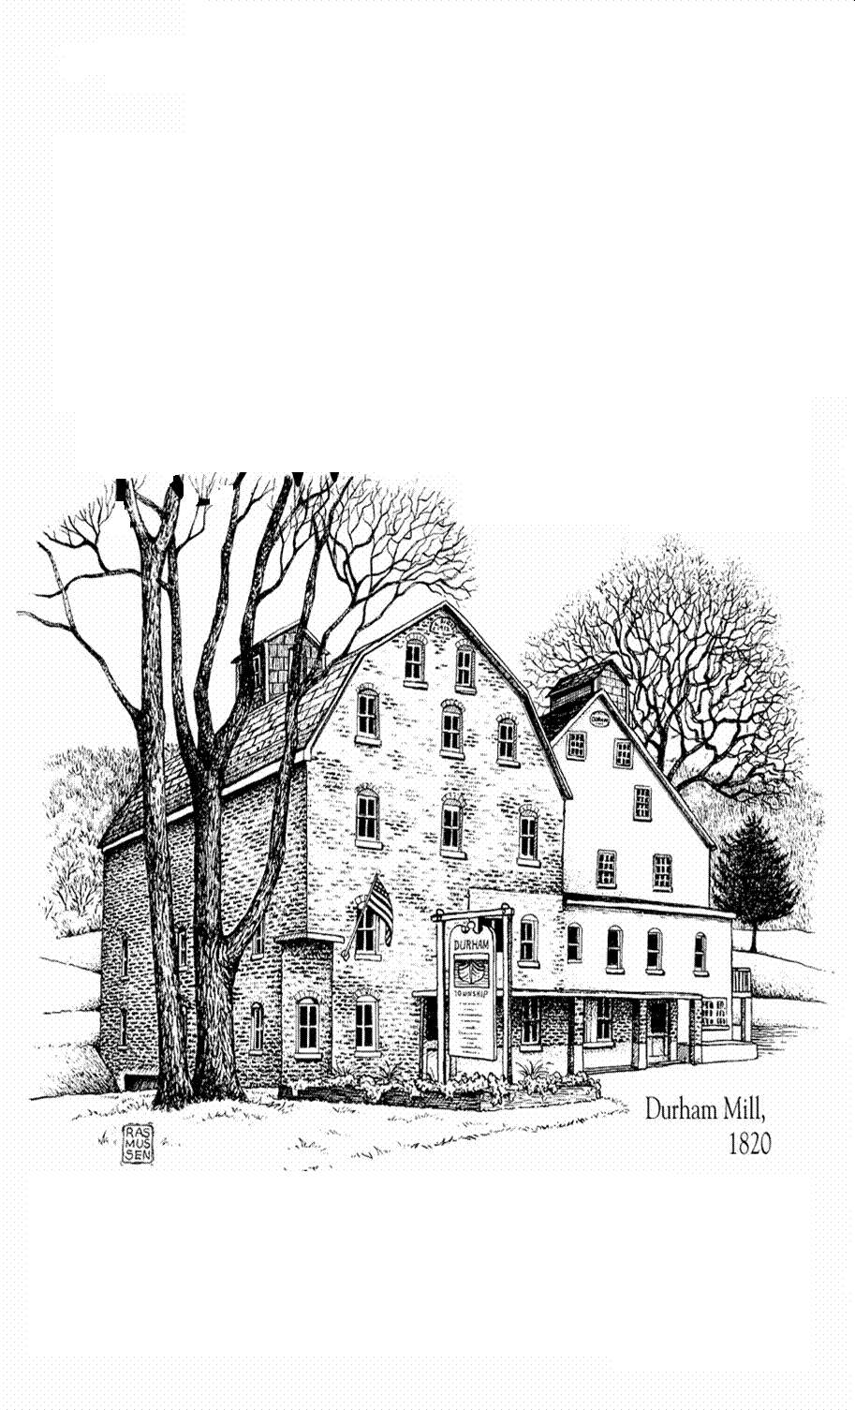

(TOWNSHIP USE ONLY)

ASSIGNED SPACE NO. ______________

ALL Spaces are OUTSIDE on Village Green

DURHAM TOWNSHIP COMMUNITY DAY P.O. Box 4, Durham, PA 18039. (610) 346-8911

E-MAIL: [info@durhamtownship.org](mailto:info@durhamtownship.org) Fax: 610-346-8941

Durham Township invites you to join us once again to be a part of Durham Community Day which will be held on Saturday, October 12, 2024, from 1:00 PM until 4:00 PM at the Durham Gristmill and on the Village Green. **Please return this completed form along with your check made payable to:**

DURHAM TOWNSHIP

P.O. Box 4

Durham, PA 18039

To ensure your ad space and table location please remit ASAP.

**NOTE: You must provide your own table and chairs. (Set-up time no earlier than 12 Noon) We suggest a tent if the weather is unfavorable. Event will be rain or shine.**

VENDOR / CRAFTER NAME ­_____________________________________________________________

ADDRESS ______________________________________________________________________________

CONTACT NAME: ________________________ TELEPHONE: ( ) __________________________

TYPE OF CRAFT OR EXHIBIT: __________________________________________________________

VENDOR SPACE ___ AD ___ (PLEASE CHECK APPROPRIATE BOX(s))

___ 10’ x 10’ Space...................$10.00 *(No refunds if rained-out)*

___ Business Card Ad .............$25.00 ___ Full Page Ad ..............................$100.00

___ Half Page Ad ...................$50.00 ___ Full Page Ad on Back Cover.......$200.00

AMOUNT ENCLOSED: $ ______________________ □ No Charge for Verified Non-Profit

NOTE: AD ONLY sponsors should submit copy of ad with artwork or business card.

 FREE (with space) PROGRAM AD DESCRIPTION OF BUSINESS/PRODUCT (in 25 words or less).

Sample format suggestion for the above FREE AD:

Spinning Yarn, 222 Needle Way, Knitsville, PA, 18000, 610-888-7777, Hours: Noon to 3:00 p.m. We provide all of your knitting and crocheting needs.